**10 SCIENCE 2016 Accelerated**

### CHEMISTRY TEST TWO

Name: _____________________________ Mark: /54

**SECTION A: MULTIPLE CHOICE (15 marks)**

**Use a ball point or ink pen to mark an X** on the letter that represents the best answer from the choice of answers . Marks are not deducted for wrong answers.

|  |  |
| --- | --- |
| Question | Answer |
| 1 | A B C D |
| 2 | A B C D |
| 3 | A B C D |
| 4 | A B C D |
| 5 | A B C D |
| 6 | A B C D |
| 7 | A B C D |
| 8 | A B C D |
| 9 | A B C D |
| 10 | A B C D |
| 11 | A B C D |
| 12 | A B C D |
| 13 | A B C D |
| 14 | A B C D |
| 15 | A B C D |

**1.** Select the incorrect statement about catalysts.

(a) Catalysts increase the amount of energy needed to convert reactants into products.

(b) Catalysts make it easier for reactant molecules to collide and form products.

(c) Catalysts speed up chemical reactions.

(d) Catalysts are not used up during reactions.

**2.** Choose the missing words for this statement.

If a solid **______________** is divided into smaller pieces, more of the solid is exposed to the liquid reactant and the rate of reaction is **_______________**.

(a) Reactant, increased.

(b) Product, increased.

(c) Product, decreased.

(d) Reactant, decreased.

**3.** Choose the correct definition for ‘ions’.

(a) Particles that have the same number of protons and electrons.

(b) Particles that have no charge.

(c) Particles that have more neutrons than protons.

(d) Particles that have a charge.

**4.** An atom that loses electrons to become an ion has a :

(a) Negative charge.

(b) Positive charge.

(c) No charge.

(d) Neutral charge.

**5.** AgNO3 has the compound name:

(a) Argon nitrite.

(b) Silver nitrate.

(c) Silver nitrite.

(d) Argon nitrate.

**6.** The chemical formula for boron oxide is:

(a) BO

(b) B2O3

(c) BaO

(d) B3O2

**7.** The electrons found in the outermost shell of an atom are called the:

(a) valence electrons.

(b) cations.

(c) anions.

(d) reactants.

**8.** The general name for the chemicals that take part in a chemical reaction is:

(a) atoms.

(b) molecules.

(c) products.

(d) reactants.

**9.** Which of the following only contains radical ions?

(a) OH-, CO3-, H2, PO4-3.

(b) PO4-3, SO4-2, OH-, NH4+

(c) OH-, CO3-, Cl2, PO4-3.

(d) NH4+, CO3-, H2, PO4-3.

**10.** Choose the equation that is not balanced.

(a) C5H12 + 4O2 🡪 CO2 + 6H2O

(b) Mg + 2HCL 🡪 MgCl2 + H2

(c) 4Al + 3O2 🡪 2Al2O3

(d) 2Zn + O2 🡪 2ZnO

Look at the diagram below and use it to answer the 2 questions that follow.

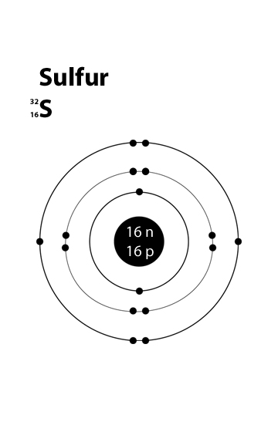

11. To gain an electron configuration like that of a Nobel gas this element will need to:

a. Gain 3 electrons.

b. lose 3 electrons.

c. Gain 2 electrons.

d. Lose 2 electrons.

12. If this atom were to become an ion it is likely to form:

a. a positive ion.

b. a negative ion.

c. a radical ion.

d. a Photon

13. With covalent bonding.

a. atoms share electrons.

b. particles with different charges are held together due to charge difference.

c. atoms “float” in a “sea” of electrons.

d. atoms can only from diatomic gasses.

14. Which of the following only contains diatomic gasses?

a. Oxygen gas, methane and chlorine gas.

b. Nitrogen gas, chlorine gas, methane and Helium gas.

c. Nitrogen gas, chlorine gas, oxygen gas and hydrogen gas.

d. Methane, helium gas, barium nitrate and hydrogen gas.

Look at this diagram and use it to answer question 15.

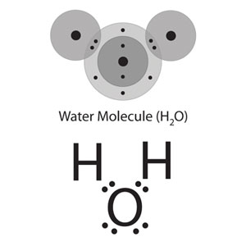

15. The diagram above:

a. shows an electron dot diagram of the covalent water molecule.

b. show the electron configuration of the ionic water molecule.

c. shows the electron dot diagram of the covalent methane molecule.

d. show the ionic bonding in a peroxide molecule.

SECTION B: SHORT ANSWER (39 marks)

1. List three things that affect the rate of chemical reactions. (3 marks)

_______________________________________________________________________________

________________________________________________________________________________

________________________________________________________________________________

2. Complete the table below

|  |  |  |  |
| --- | --- | --- | --- |
| Name | Positive ion | Negative ion | Formula |
| Sodium chloride |  |  |  |
| Calcium chloride |  |  |  |
| Aluminum oxide |  |  |  |
| Silver oxide |  |  |  |
| Iron(III) oxide |  |  |  |
| Sodium hydroxide |  |  |  |
| Calcium hydroxide |  |  |  |
| Calcium sulfate |  |  |  |
| Iron(III) carbonate |  |  |  |
| Aluminum sulfate |  |  |  |
| Calcium phosphate |  |  |  |
| Ammonium phosphate |  |  |  |
|  | 1 mark | 1 mark | 12 marks |

**(14 marks)**

**3.** Balance the chemical equations below. (7 marks)

**a)** Na + Cl2 🡪 NaCl

**b)** Al + O2 🡪 Al2O3

**c)** S8 + O2 🡪 SO2

**d)** Ca + H20 🡪 Ca(OH)2 + H2

**e)** V2O5 + CaS 🡪 CaO + V2S5

**f)** Fe2O3 + C 🡪 CO2 + Fe

**g)** Al + HCl 🡪 AlCl3 + H2

5. For the word equations below. Write them out as formula equations and then balance them (if they need to be balanced).

(8 marks)

1. Silver metal + Hydrochloric acid 🡪 Sliver chloride + hydrogen gas
2. Aluminium metal + Hydrochloric acid 🡪 Aluminium chloride + Hydrogen gas
3. Silver sulphate + calcium metal 🡪 calcium sulphate + silver metal
4. Calcium + Nitric acid 🡪 Calcium nitrate + hydrogen gas

6. Carbon has 4 valence electrons. Oxygen has 6 valence electrons. If methane is a covalent compound draw the electron dot diagram for methane into the space below.

(2 marks)

**9.** A chemist is developing a new chemical reaction for converting iron ore into iron metal. She wants to work out how adding a catalyst changes the rate of reaction. To do this, she measures the amount of iron metal produced by the chemical reaction every minute for the first 5 minutes. Her data is in the table below.

Draw a graph using the information from the table below. (5 marks)

|  |  |
| --- | --- |
| **Time (minutes)** | **Iron produced (g)** |
| 0 | 0 |
| 1 | 20 |
| 2 | 42 |
| 3 | 53 |
| 4 | 60 |
| 5 | 68 |

[](http://www.google.com.au/url?sa=i&rct=j&q=graph+paper&source=images&cd=&cad=rja&uact=8&docid=bnDyK-WDEHhooM&tbnid=OH_xw5ZTcFEuvM:&ved=0CAUQjRw&url=http://virtualmathtutor.blogspot.com/2010/11/how-to-draw-circle-without-compass.html&ei=RKw4U5fxF8fClQWCrIGoCQ&psig=AFQjCNHahbsWAgdANQM5RZCXw4z48cLLBw&ust=1396309252654415)

**Table of common ions**

|  |  |
| --- | --- |
| **+1 charge** | **- 1 charge** |
| Hydrogen H+  Lithium Li+  Sodium Na+  Potassium K+  Copper (I) Cu+  Silver Ag+  Ammonium NH4+ | Fluoride F-  ChlorideCl-  Bromide Br-  Iodide I-  Hydride H-  Hydroxide OH-  Nitrite NO2-  Nitrate NO3- |
| **+2 charge** | **- 2 charge** |
| Manganese Mn2+  Magnesium Mg2+  Calcium Ca2+  Barium Ba2+  Zinc Zn2+  Copper (II) Cu2+  Mercury (II) Hg2+  Iron (II) Fe2+  Tin (II) Sn2+  Lead (II) Pb2+  Nickel (II) Ni2+  Beryllium Be2+ | Oxide O2-  Sulfide S2-  Carbonate CO32-  Sulfate SO42-  Sulfite SO32- |
| **+3 charge** | **- 3 charge** |
| Aluminum Al3+  Iron (III) Fe3+  Chromium (III) Cr3+  Boron B3+ | Nitride N3-  Phosphate PO43-  Phosphide P3- |